Circuit Court
Majority of Jury Trials

* Civil cases (over $30,000) * Juvenile dependency and delinquency
* Felonies * Probate / guardianship / mental health
* Family law matters * Appeals from County Court

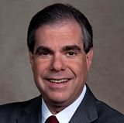 | Jaimie Goodman - Grp. 30  Admitted to the Bar 5/7/92
Adam Myron - Grp. 30
Admitted to the Bar 10/27/04

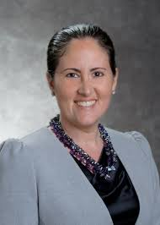 | Caryn Siperstein - Grp. 30  Admitted to the Bar 12/25/14

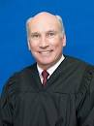 | Jeffrey Gillen - Grp. 16  Admitted to the Bar 10/7/97
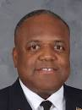 | Henry Quinn Johnson - Grp. 16  Admitted to the Bar 9/22/98

County Courts

* Civil cases (up to $30,000) * Small claims (up to $8,000)
* Misdemeanors * Traffic

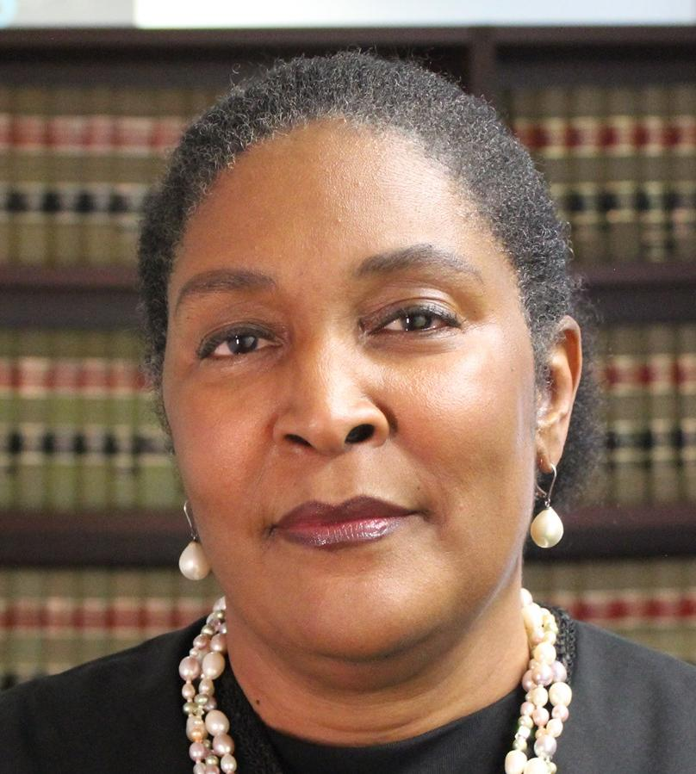 | Debra Stephens - Grp. 12  Admitted to the Bar 10/6/87
Jaianna Seaborne - Grp. 12
Admitted to the Bar 9/19/06

VOTE AUGUST 18, 2020

